**Student: Duong Le**

**IT360**

**Oct 11, 2016**

**Personalization Exercise (Relevant Video: “User Personalization”)**

Goal: Be able to customize the ribbon, navigation pane, Factboxes and Fasttabs (and fields in fasttabs).

1. 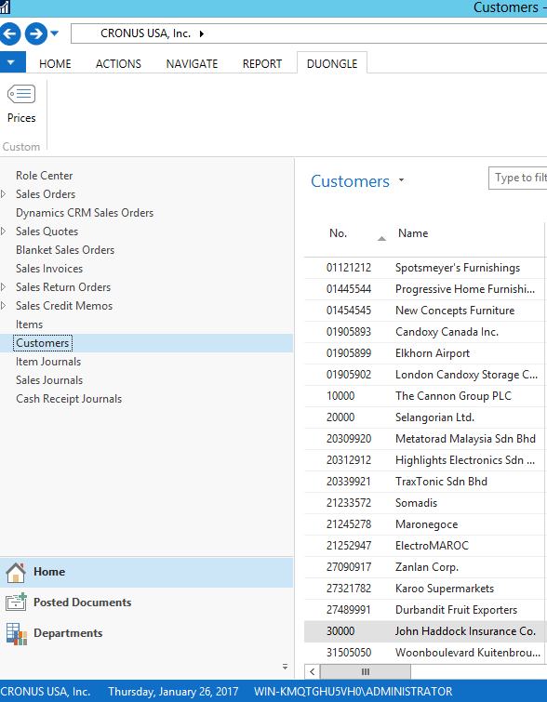Customize the Ribbon for Customer card. (Create new tab (“NAME”), new group (“Custom”) and add any information you choose in this “Custom” group

1. Customize navigation pane to create new menu (NAME-Reminders) and populate it with at least 3 lists

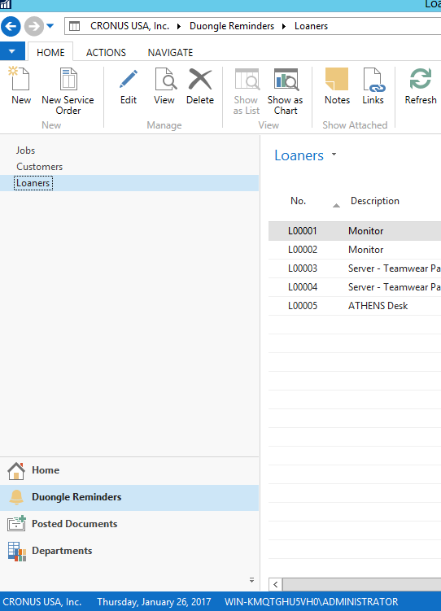

1. Customize the fasttabs so that you change the fields that are ‘promoted’ (i.e. shown on the fasttab itself). Promote ‘Profit %’ on Inventory FastTab for Item Card Bicycle. See below for an example.

